Retail Sales Performance Analysis
Project Overview
● Objective:
Analyze historical retail sales data to derive actionable insights.
- Background:
The organization seeks to better understand product performance, regional sales trends, and customer buying patterns. This analysis will help optimize inventory planning, promotional strategies, and regional targeting for improved revenue.
Step-by-Step Plan
Step 1: Source Data Explanation
1. Task:
- Download your source file (sales.csv) from here.
We don't have highlighted columns in the above CSV and those are not required as of now.
Column Name | Data Type | Description
transaction_id | String | Unique identifier for each transaction.
date | Date | Date of the transaction (format: YYYY-MM-DD).
region | String | Region where the sale took place (e.g., North, South, East, West).
product | String | Name of the product sold.
category | String | Product category (e.g., Electronics, Furniture, Clothing).
units_sold | Integer | Number of units sold in the transaction.
unit_price | Float | Price per unit of the product sold.
total_sales | Float | (Optional) Total sale amount. Can also be computed as units_sold * unit_price.
sales_rep | String | Name or ID of the sales representative (optional, for team-level insights).
2. Data Structure:Step 2: Initial Data Analysis
1. Task:
○ Analyze the .csv file to inspect the data thoroughly.(Manually)
○ Identify the gaps(if any) and also review for null values or incorrect data formats.(Manually)
Step 3: Define Program Process
1. Task:
○ Store the source data in AWS
○ Design a production level function oriented python program which can perform transformations and provide business insights using visualization.
○ The programming should be done in Snowpark (snowflake offered service).
○ The program should be able to handle all possible errors/exceptions.
○ Design according to below requirements:
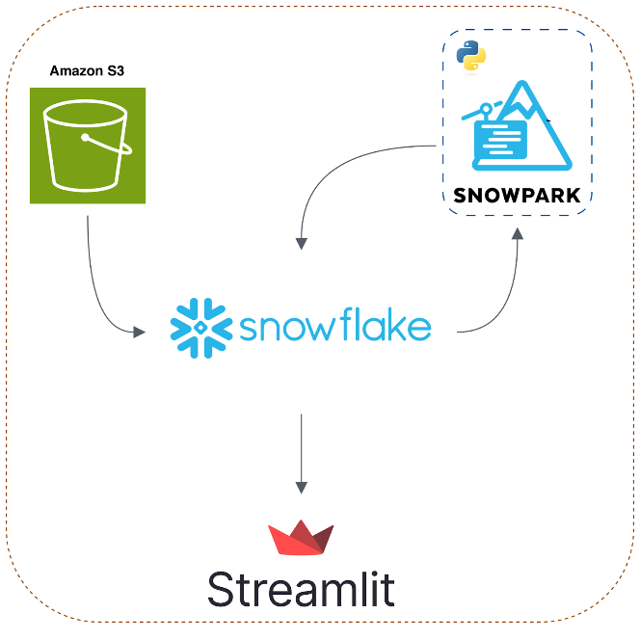
The entire logic should be performed using python programming. Find the steps to setup Snowpark here.
The entire process should follow data engineering architecture of loading/extraction of data, transformation and loading followed by visualization.
The storage layer can be in AWS, transformations must be in Snowflake.
No BI tools should be used for visualization. Use the documentation for Streamlit in Snowflake from here.Tutorial video link here.
Step 4: Build the Data Analysis pipeline
Deliverables:
- Create a working pipeline that:
  - Loads data into storage
  - Adds derived columns (month, etc.) as per requirement planned by you
  - Performs groupings and aggregations and other transformations
  - Visualizes trends
Step 5: Define and Calculate Metrics
5.1 Product Sales Leaderboard
Goal: Identify which products generate the highest revenue
Why it matters: Helps prioritize marketing and inventory efforts
How to do it:
- Add a new column to represent total sales (e.g., units sold × unit price)
- Group the data by product name
- Calculate total sales per product
- Sort the results in descending order of total sales
- Visualize with a bar chart to highlight top products
5.2 Regional Sales Comparison
Goal: Understand how each region performs in terms of total sales
Why it matters: Identifies strong and weak geographical markets
How to do it:
- Group the dataset by region
- Aggregate total revenue for each region
- Compare and visualize the sales distribution using a bar or pie chart
5.3 Monthly Trend Analysis
Goal: Spot seasonal patterns and monthly performance trends
Why it matters: Helps plan for demand cycles and promotional timing
How to do it:
- Convert the transaction date to datetime format (if not already)
- Extract the month and year from the date column
- Group the data by month/year and calculate total sales
- Plot the results to visualize trends over time (e.g., line chart)
5.4 Units Sold vs Revenue
Goal: Discover if high volume always translates to high revenue
Why it matters: Helps identify high-margin vs. low-margin products
How to do it:
- Group the data by product
- Calculate both total units sold and total revenue per product
- Compare these values side by side (e.g., in a dataframe or bar chart)
- Look for discrepancies where units sold are high but revenue is low (or vice versa)
5.5 Average Order Value (AOV)
Goal: Estimate how much value each unit sale typically generates
Why it matters: Useful for understanding customer behavior and pricing strategies
How to do it:
- Calculate AOV using the formula: total revenue ÷ total units sold
- Perform this calculation for the entire dataset
- Optionally, break it down by region or product category for deeper insight
- Compare AOV values to find areas of opportunity
Step 6: Build the Dashboard (Streamlit)
1. Product Sales Performance
- Question: Which products bring the most revenue?
- Visualization Ideas:
  - Bar chart comparing product names with total revenue
  - Pie chart showing sales percentage per product
2. Monthly Trends
- Question: Are there seasonal sales patterns?
- Visualization Ideas:
  - Line chart showing month-over-month revenue
  - Area chart to highlight growth trends
3. Regional Insights
- Question: Which regions perform the best?
- Visualization Ideas:
  - Horizontal bar chart with region vs revenue
  - Stacked bar comparing product sales within each region
Step 7: Submission and Review
1. Task:
○ Submit all deliverables, including:
■ Code files (python scripts).
■ Setup Configurations (if any)
■ Final dashboard.
2. Instructions:
○ Ensure all files are properly named and documented.
○ Include a short video or presentation explaining the work.
○ Explain ‘WHY’ behind each tech stack used in your design

Objective:
- Analyze historical retail sales data to derive actionable insights.
- Goal: Help optimize inventory planning, promotional strategies, and regional targeting.

Python notebook:
# Retail Sales Performance Analysis Pipeline

# Import Libraries
import pandas as pd
import streamlit as st
import plotly.express as px
from snowflake.snowpark import Session
from snowflake.snowpark.functions import col, sum as sf_sum, to_date, month, year

# Snowflake Connection (Snowpark)
connection_parameters = {
"account": "YOUR_ACCOUNT",
"user": "YOUR_USER",
"password": "YOUR_PASSWORD",
"role": "YOUR_ROLE",
"warehouse": "YOUR_WAREHOUSE",
"database": "YOUR_DATABASE",
"schema": "YOUR_SCHEMA"
}

session = Session.builder.configs(connection_parameters).create()

# Load CSV from AWS S3
# Replace 's3://your-bucket/sales.csv' with your path
df_sales = pd.read_csv("s3://your-bucket/sales.csv")

# Initial Data Cleaning
# Fill missing values if necessary
df_sales['units_sold'].fillna(0, inplace=True)
df_sales['unit_price'].fillna(0, inplace=True)
df_sales['total_sales'] = df_sales['total_sales'].fillna(df_sales['units_sold'] * df_sales['unit_price'])
df_sales['date'] = pd.to_datetime(df_sales['date'], errors='coerce')

# Load Data into Snowflake
session.write_pandas(df_sales, "SALES_RAW", auto_create_table=True, overwrite=True)

# Transformations in Snowpark
sales_df = session.table("SALES_RAW")

# Add derived columns
sales_df = sales_df.with_column("month", month(col("date"))) \
.with_column("year", year(col("date"))) \
.with_column("total_sales_calc", col("units_sold") * col("unit_price"))

# Metrics Calculation

# 7.1 Product Sales Leaderboard
product_sales = sales_df.group_by("product") \
.agg(sf_sum("total_sales_calc").alias("total_sales")) \
.sort(col("total_sales").desc())

product_sales_pd = product_sales.to_pandas()

# 7.2 Regional Sales Comparison
region_sales = sales_df.group_by("region") \
.agg(sf_sum("total_sales_calc").alias("total_sales")) \
.sort(col("total_sales").desc())
region_sales_pd = region_sales.to_pandas()

# 7.3 Monthly Trend Analysis
monthly_sales = sales_df.group_by("year", "month") \
.agg(sf_sum("total_sales_calc").alias("total_sales")) \
.sort(col("year").asc(), col("month").asc())
monthly_sales_pd = monthly_sales.to_pandas()
monthly_sales_pd['month_year'] = monthly_sales_pd['year'].astype(str) + '-' + monthly_sales_pd['month'].astype(str).str.zfill(2)

# 7.4 Units Sold vs Revenue
product_units_revenue = sales_df.group_by("product") \
.agg(sf_sum("units_sold").alias("total_units"),
sf_sum("total_sales_calc").alias("total_sales")) \
.sort(col("total_sales").desc())
product_units_revenue_pd = product_units_revenue.to_pandas()

# 7.5 Average Order Value (AOV)
total_revenue = sales_df.agg(sf_sum("total_sales_calc").alias("total_revenue")).to_pandas()["total_revenue"].values[0]
total_units = sales_df.agg(sf_sum("units_sold").alias("total_units")).to_pandas()["total_units"].values[0]
AOV = total_revenue / total_units if total_units > 0 else 0

# Streamlit Dashboard
st.title("Retail Sales Performance Dashboard")

# Product Sales Leaderboard
st.subheader("Top Products by Revenue")
fig1 = px.bar(product_sales_pd, x='product', y='total_sales', title="Product Sales Leaderboard")
st.plotly_chart(fig1)

# Regional Sales Comparison
st.subheader("Regional Sales Comparison")
fig2 = px.bar(region_sales_pd, x='region', y='total_sales', title="Total Revenue by Region")
st.plotly_chart(fig2)

# Monthly Trends
st.subheader("Monthly Sales Trends")
fig3 = px.line(monthly_sales_pd, x='month_year', y='total_sales', title="Monthly Revenue Trends")
st.plotly_chart(fig3)

# Units Sold vs Revenue
st.subheader("Units Sold vs Revenue per Product")
fig4 = px.bar(product_units_revenue_pd, x='product', y=['total_units','total_sales'], barmode='group', title="Units vs Revenue")
st.plotly_chart(fig4)

# Average Order Value
st.subheader("Average Order Value (AOV)")
st.write(f"The Average Order Value across all sales is: ${AOV:.2f}")

